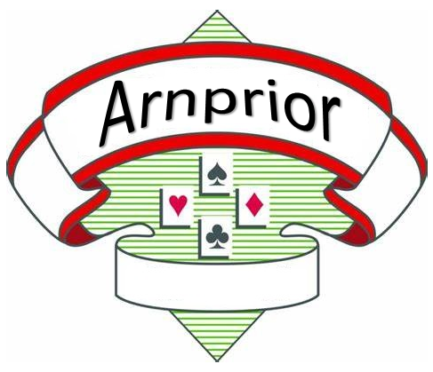
May 4-7, 2023
Nick Smith Centre
77 James St.
Arnprior, Ontario

Arnprior IN Regional and Open Sectional Tournaments

Pre-Registration (optional)

Note: To pre-register, you must be prepared to sign-up for two sessions. If you only want to play in one session, you will have register at the tournament.

Step 1: Log in to ACBL
- Go to ACBL.org.
- Click on My ACBL on the top bar. The Login page appears.
- Enter your Member No and Password.
- Click Submit.

Step 2: Register for Tournament
- Click this link (ctrl+click): Find a Tournament.
- Click on the words Avoid the Line.
- In the left-hand Filters box, select May.
- On the right, scroll down to Arnprior IN Regional (less than 750 pts) or Arnprior Sectional.
- Click on the Buy Entries button.
- Click the Select button next to your games.
- Enter your partner’s name or ID in the box.
- Click the Add Entry button.
- Repeat steps 6 – 8, for any additional sessions.
- When done, click the Pay Now button.

